SOFTWARE DEVELOPMENT PRACTICES

FLIGHT TICKET RESERVATION SYSTEM

Prepared by

V.Shriram

Yadhu Krishna.U.S

Voggu Teja.V

Sudhan Gowtham

Sudhakaran

(IT C)

**Objective:**

Build a web application for flight ticket reservation.

**Users of the system:**

* Public
* Admin

**Functional Requirements:**

* The website allows users to check for flights available to travel to locations they wish to travel.
* It allows the users to book tickets for respective flights.
* It allows users to cancel the booked tickets in case of any inconvenience.
* The website should have a sign in/sign up page,home page from where the user can navigate as per his needs.
* The website should store the users details like:

1. Name
2. Date of Birth
3. Gender
4. Address
5. Marital Status
6. State
7. Pincode
8. Email

* In case the user does not have an account to sign in,the user can sign up.

**Non-Functional Requirements:**

1.Security

* Apps must have a publicly accessible privacy policy that comprehensively discloses the access, collection, use and sharing of personal and sensitive user data.
* Transactions made for booking tickets are encrypted and secure.
* User accounts can only be accessed if entered with the correct password.

2.Portability

* The website will be available to anyone who has a browser and internet connection. A user could use any device.

3.Standard Features:

* Filters for non-stop travel or travel with stops.
* Filters for different airlines for customer preference.
* Filters for flight departure time,arrival time

4..Logging:

* The user can login to their account using their registered mobile or registered email provided with the correct password.

5.Browser Compatible:

All Browsers.

6.Technology stack:

* HTML
* CSS
* Javascript
* PHP

Validations:

* Mobile number validation should be done.
* Password validation should be done.
* Email validation should be done.

**Screenshots:**

Login:

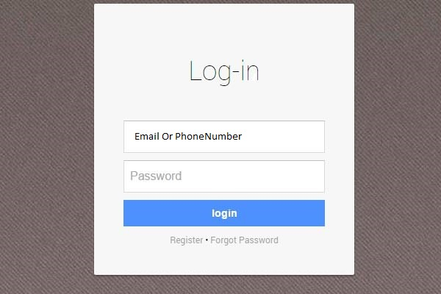

Searching for Flights:

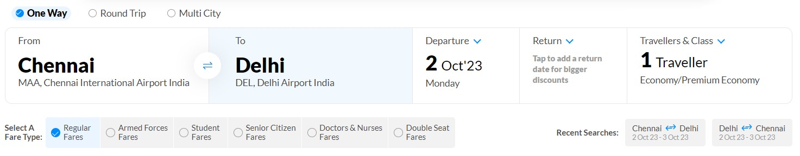

Filters:

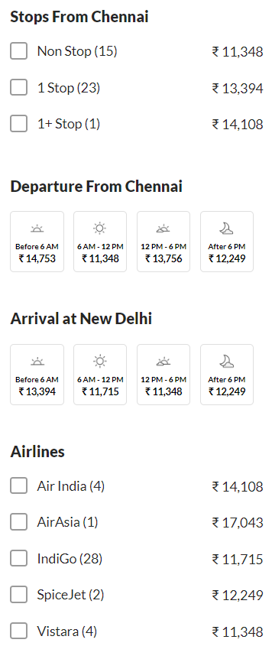

**Conclusion:**

This project is developed successfully and the performance is found to be satisfactory.This project is designed to meet the requirements of ticket reservation. It has been developed in PHP for backend and HTML,CSS,Javascript are used for frontend.PHP has advantages such as enhanced performance, scalability, built- in security and simplicity.

The user will be able to search for available flight for their travel and book tickets for travelling in respective flights for which they wish.